1. Pull a image from docker hub and run it in docker playground.

2.Create a docker file for the job portal application and deploy it in Docker desktop application.

### Application to be deployed in Docker.

# Building the application : docker build -t flask_app .

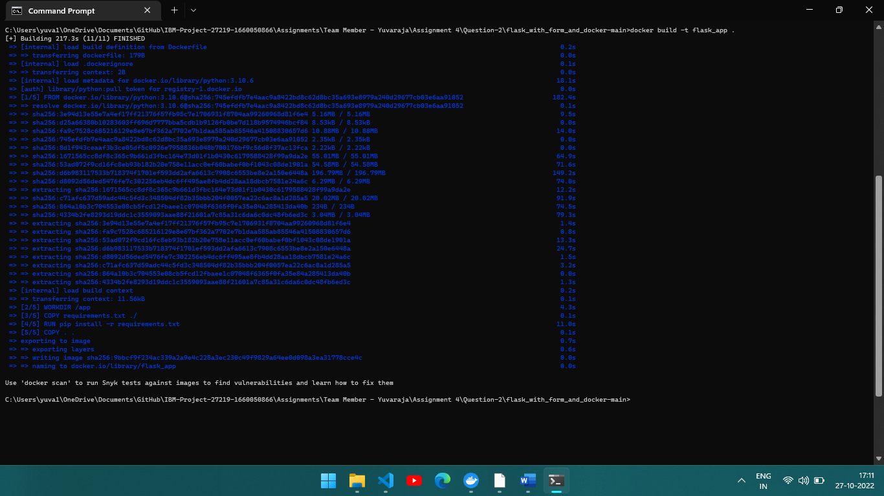

## Image of the deployed application.

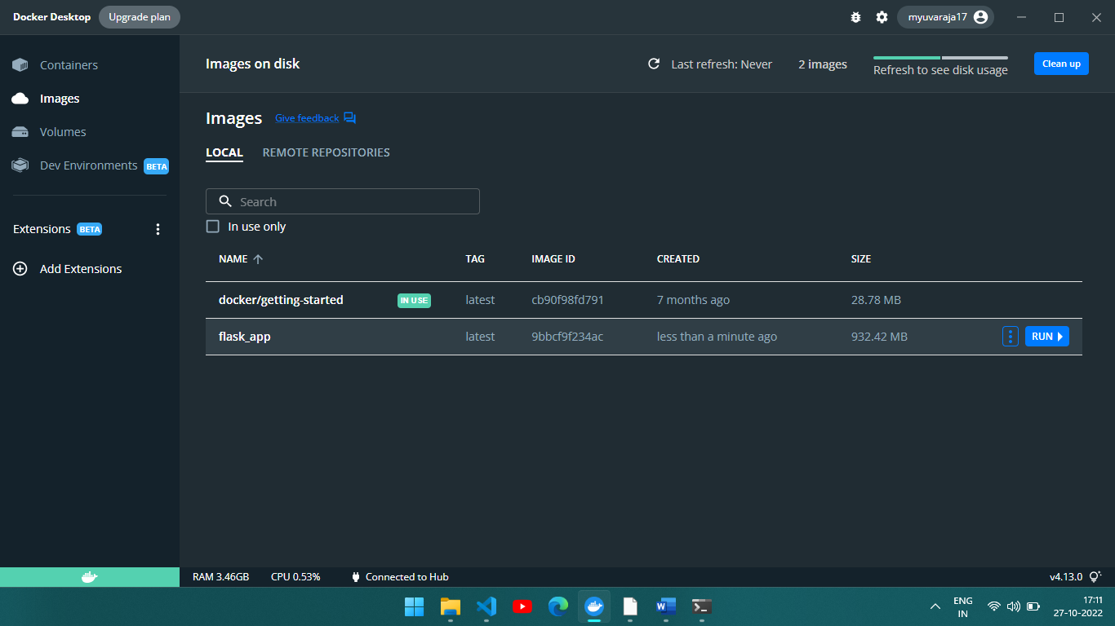

The Pushed application is running in docker

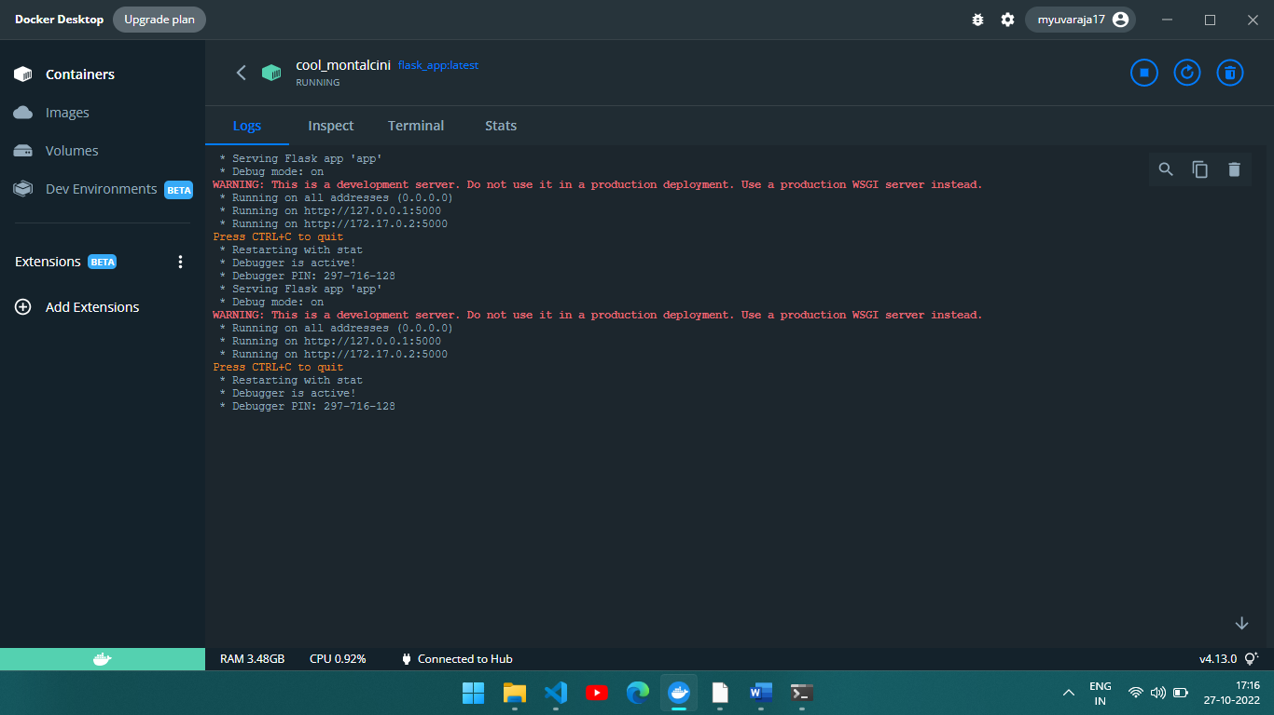

Run using cmd

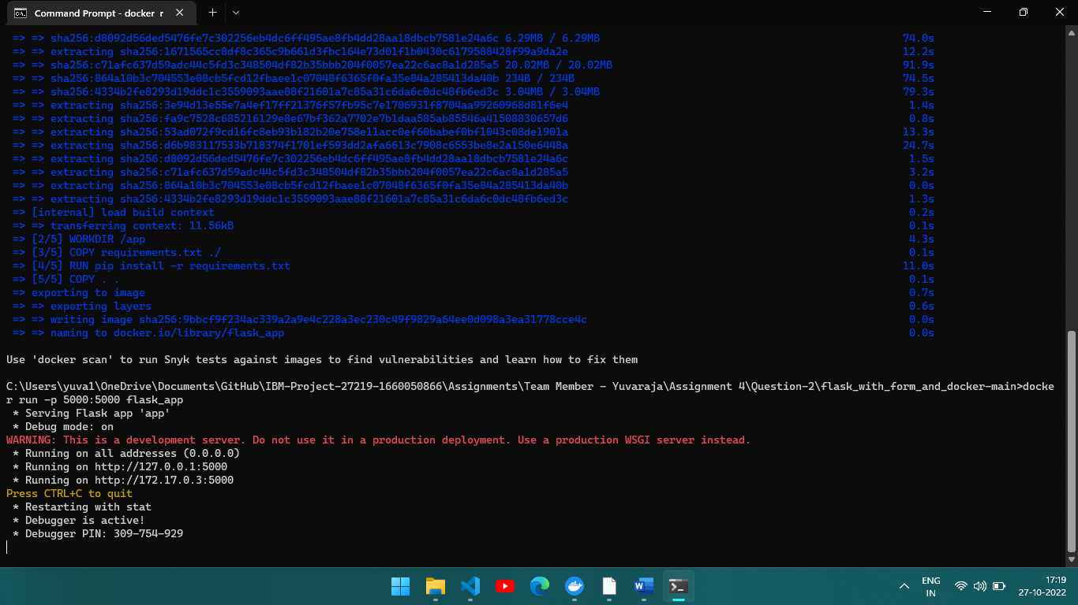

3.